Project Report

FALL 2024

CMPS405  
Phase 2

|  |  |  |
| --- | --- | --- |
| **student name** | **Student part in the Project** | **participation percentage** |
| Amer Alzawawi  2205054 | Client1.java  Revised client2.java | 25% |
| Ahmad Almashhadani  202203014 | Server.java  Revised all outputs | 25% |
| Abdallah Alkanani  202204061 | Client2.java  Revised client1.java edited scripts in phase 1 to be compatible with phase 2 | 25% |
| Ali Ghazi  202209865 | Server.java Revised all outputs | 25% |

***Shell Scripts Testing:***

Network.sh:

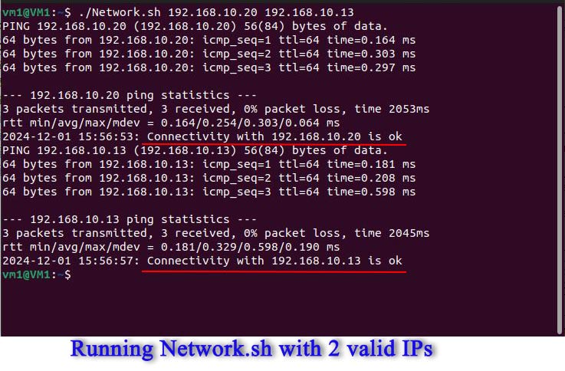

The script requested password to restart the machine, but pressed crtl c to disable in this case to demonstrate.  
System.sh:

login.sh:

Check.sh:

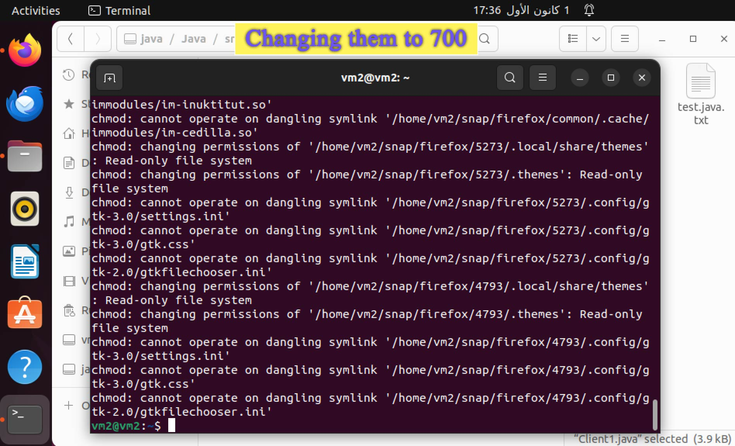

Search.sh:

After running:  
 checking Qu mail inbox:

Clientinfo.sh:

***Java Testing:***

**Server.java:**

Running Server.java and connecting client1.java and client2.java

Tested the connection with client1 and client2 with Network.sh

**Client1.java:**

Then entering a right username and password:

Login.sh finished and printed the output in java

Then client1.java will run check.sh:

Finished check.sh

Client1 entered “y” to request System information and then entered sftp password, and the received file got displayed in the terminal.

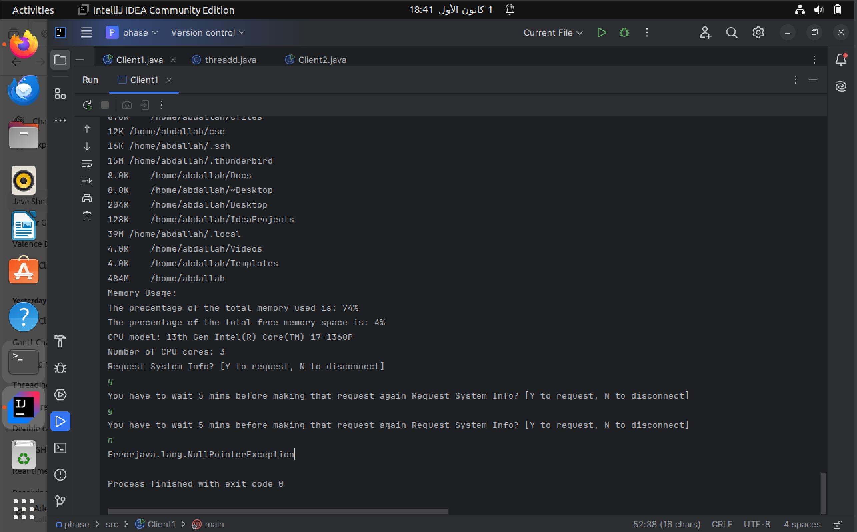

Requesting again after the first one -> rejected and have to wait 5 minutes

Then exited.

**Client2.java:**

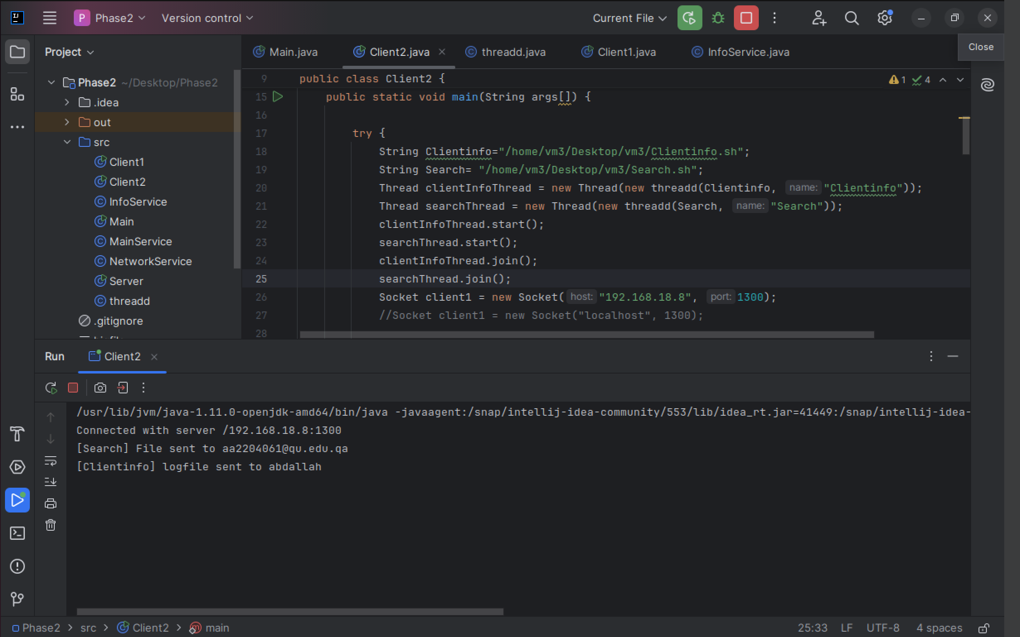

Run client2.java, finished executing search.sh and Clientinfo.sh

Connected to the server

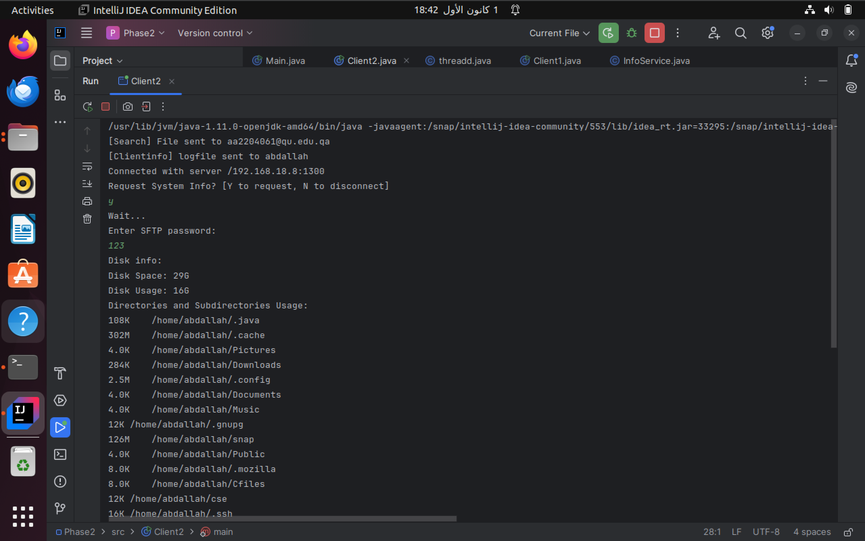

Requested info from server got the info and then displayed it

After requesting first it is forced to wait 5 minutes

Then exited.

**

After the two clients got disconnected.